### Empowering Economic Growth: Ministry of Investments, Saudi Arabia, and SayeNvest Caps Advisory Limited Join Forces

The Ministry of Investments, Saudi Arabia, and SayeNvest Caps Advisory Limited have forged a strategic partnership to drive economic growth and promote investment opportunities in Saudi Arabia.

This landmark collaboration brings together the expertise and resources of two leading institutions dedicated to driving innovation, entrepreneurship, and sustainable development in the Kingdom. The MOU signifies a shared commitment to unlocking the full potential of Saudi Arabia's economy and creating a conducive environment for investment and business growth.

This collaboration, formalised through the signing of a Memorandum of Understanding (MOU), underscores the shared vision of both organisations to unlock the Kingdom's potential as a global investment destination. By leveraging their respective strengths and capabilities, the Ministry of Investments and SayeNvest Caps Advisory Limited aim to stimulate innovation, entrepreneurship, and job creation across various sectors of the Saudi economy.

The MOU lays the foundation for a series of joint initiatives, including:

Identifying and promoting investment opportunities in priority sectors such as technology, healthcare, energy, and tourism.

Providing support and resources to startups and SMEs to foster growth and innovation.

Facilitating partnerships between local and international investors to drive sustainable development projects in the Kingdom.

At the signing ceremony in Riyadh this week, HE Saleh Al-Khabti, Deputy Minister of Investment

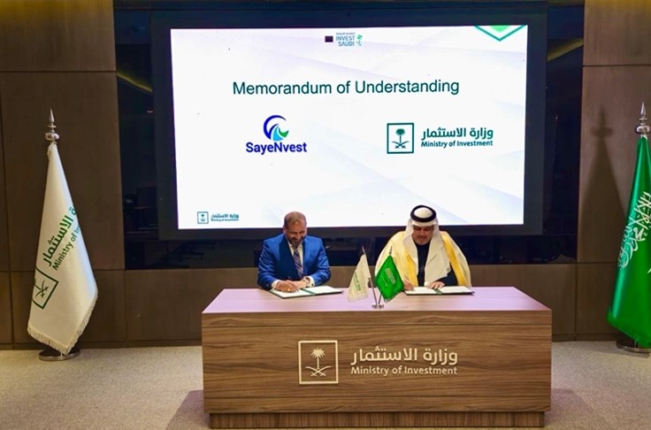

Transactions for the KSA and Rakeshh Gupta, Chief Executive Officer of SayeNvest Caps Advisory Limited, underscored this partnership's transformative potential.

It marks a significant milestone in Saudi Arabia’s journey toward becoming a global investment destination. It showcases the Kingdom's commitment to growth and development and creates global enterprises operating out of the Kingdom.

For more information about this partnership and its impact on the Saudi economy, please contact:

Contacts

For Ministry of Investment, Kingdom of Saudi Arabia:

Investor and Media Contact: [InvestorCare@misa.gov.sa](mailto:InvestorCare@misa.gov.sa)

For SayeNvest Caps Advisory Global

Investor Contact:

Mr Rakeshh Gupta [Chairmanoffice@sayenvestcaps.com](mailto:Chairmanoffice@sayenvestcaps.com)

Media Contact: Eugine Orgend [eo@sayenvestcaps.com](mailto:eo@sayenvestcaps.com)

About SayeNvest Caps: SayeNvest Caps Advisory Limited is a leading global boutique, bespoke and discreet advisory firm providing quality strategic and financial advisory services specialising in fund and capital raising through their global institutional investors and family office relationships. SayeNvest Caps Advisory operates out of 12 locations globally with a team of seasoned professionals and a worldwide network of partners. SayeNvest Caps empowers clients to navigate complex financial markets, optimise investment opportunities, and achieve their strategic objectives.